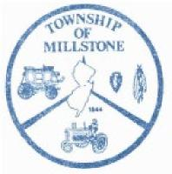
TOWNSHIP OF MILLSTONE
Construction Department
County of Monmouth
Dennis Gibson, Construction Official 470 Stagecoach Road Millstone Township, NJ 08510 Phone (732) 917-2953 Fax (609) 208-2083

A CERTIFICATE OF OCCUPANCY SHALL BE ISSUED ONLY AFTER
THE FOLLOWING IS SUBMITTED:
- Water compliance from Monmouth County Health Department.
- Septic compliance from Monmouth County Health Department.
- Soil compliance from Freehold Soil Conservation District.
- Final survey and final grading plan for engineering department. Township engineer will make final inspection of site which will include final grading, stabilization, splashblocks, curbing, driveway, apron, etc. This inspection shall be scheduled through the building department.
- Final approval from Building Subcode Official.
- Final approval from Electrical Subcode Official.
- Final approval from Fire Subcode Official.
- Final Approval from Plumbing Subcode Official.
- Home warranty from registered builder or waiver from owner if house was built by owner and will be occupied by same.
- Application for Certificate of Occupancy.
- COAH and Property Taxes paid in full.
Construction Official will review the above for completeness. The certificate will be issued only after the construction official is assured that all of the above items are in compliance.
I have read the above certificate of occupancy requirements and understand no certificate will be issued without above approvals.
Owner: (Print name)
Signature Date
Rev. 3/2021 Certificate Occupancy checklist

